**Operations Issues Tracking**

Overview

Operations Services currently uses four different tracking systems to report and track borrower-related and system issues across the organization.   In addition to having 4 disparate systems which do not exchange data with the others, each department tracks a different set of data points which makes it difficult to track and report on issues affecting the organization as a whole. This paper proposes creating a single issue tracker system by combing the four applications (PCA Complaints, Liaisons, Call Center Branch and Escalated Issues) into a single unified application used by all of Operations.

Entering a New Issue

The Enter New Issue Form is customized bases on the user’s selection made in the Select Issue Type dropdown list. However, there are certain fields which all of the applications may share in common which are outlined below. These fields would appear on the Enter New Issue Form for all 4 departments in Operations.

* **Select Issue Type:** PCA Complaints, Liaison, Escalated and Call Center Branch. This field determines which fields appear on the customized Enter New Issue Form.
* **Date Received**: The date the issue was received by Operations
* **Issue Status**: Open, Deferred, Closed, Agenda, Opened in Error
* **Assigned To**: The internal FSA staff member the issue has been assigned to
* **Date Resolved**: The date the issue was resolved/closed
* **Due Date**: The date a resolution to the issue should be provided (optional)
* **Follow-up Date**: The date a follow-up to the issue should be performed (optional)
* **Category**: FSA’s best attempt to categorize the issue (System Issue, TPD, Refunds, Report etc.)
* **Sub-category**: FSA’s best attempt to provide a sub-category of the primary category above (System Issue, TPD, Refunds, Report etc.)
* **Issue Description**: A free-form description of the issue
* **Comments**: The comments of the FSA employee the issue has been assigned to
* **Resolution**: A description of how the issue was resolved.
* **Source Org Type**: The type of individual or institution the issue originated from. This is the field that would be used largely to distinguish borrower-level issues from institutional issues. (Congressional Office, FSA, PCA, Servicer, Student, Survey)
* **Source Org Name**: The name of the institution the issue originated from (All Servicers, All PCAs)
* **Root Cause**: The cause of the issue being reported (Policy/Procedure, System, Workforce, Undetermined)
* **Source Contact Info**: The contact information of the issue source (phone, email, congressional office, pca contact etc.)

Figure 1: The primary reporting fields all departments will use

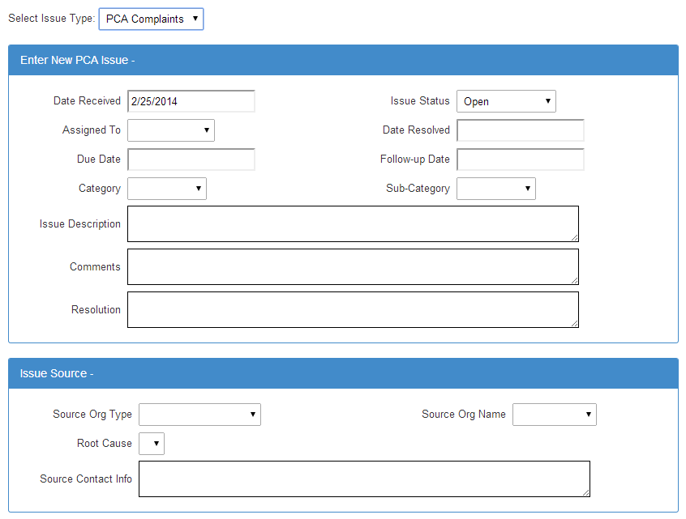

PCA Complaints

In addition to the fields in Figure 1, if the user select PCA Complaint from the Issue Type dropdown list, the following fields will be available for completion.

* **Validity**: Is the issue reported valid? (Valid, Invalid, Undetermined, Pending)
* **Received By**: Who received the issue? (Vangent, ED, PCA)
* **Complaint Source**: The source of the issue (Borrower, Attorney, Other)
* **Written/Verbal**: Was the issue received in writing or over the phone (Written, Verbal)
* **Severity**: How severe is the issue reported? (Significant, Insignificant, Severe, TPD)
* **Collector**: The name of the PCA collector
* **DCS Violation:** The DCS violation code the PCA collector violated
* **FDCPA Violation:** The FDCAP violation code the PCA collector violated
* **Complaint Type:** The complaint type being reported
* **Borrower Number:** The DMCS borrower number
* **Borrower Name:** The borrower’s name
* **School Name:** The name of the school involved (optional)
* **School Phone Number:** The phone number of the school involved (optional)

Figure 2: The reporting fields used by the PCAs

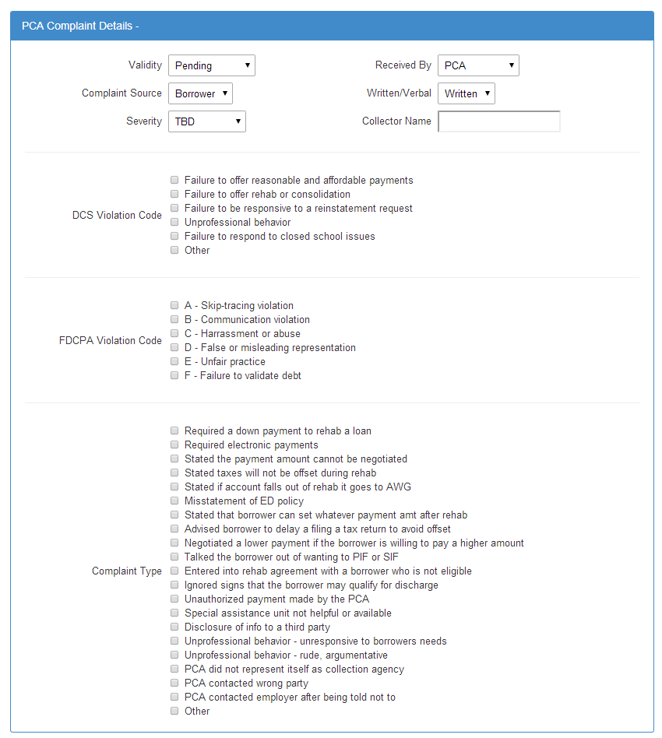

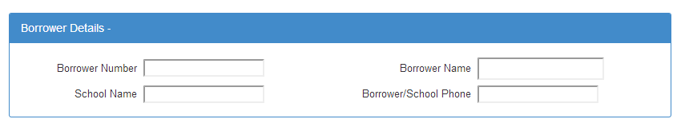

Liaison Issues

In addition to the fields in Figure 1, if the user selects Liaison from the Issue Type dropdown list, the following fields will be available for completion.

* **Affected Org**: The servicer name affected by the issue (All servicers)
* **Responsible Area**: The department within FSA responsible for resolving the issue (FSA-ProgMgt, FSA-OpServ, FSA-Ombuds, FSA-OGC, FSA-CIO, FSA-CFO, Other)
* **Ultimate Source Type**: (Borrower, NA, School)
* **Ultimate Source Name**: The name of the ultimate source
* **# Borrowers Rating**: 1-10, 11-100, 101-10000,10001-100000,100000+)
* **# Borrowers Affected**: The number of borrowers affected by the issue
* **# Loans Rating**: 1-10; 11-100; 101-10,000;10,001-100,000;100,000+)
* **# Loans Affected**: The number of loans affected by the issue
* **Financial Rating**: < $1,0000; $1,000-$10,000; $10,000-$100,000;$100,000-$1 million; $1 million+

Figure 3: The reporting fields used by the Liaisons

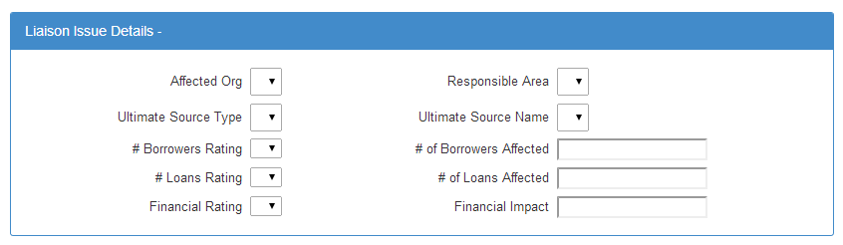

Call Center Branch

In addition to the fields in Figure 1, if the user selects Call Center Branch from the Issue Type dropdown list, the following fields will be available for completion.

* **Borrower Number:** The DMCS borrower number
* **Borrower Name:** The borrower’s name
* **School Name:** The name of the school involved (optional)
* **School Phone Number:** The phone number of the school involved (optional)

Figure 4: The reporting fields used by the Call Center Branch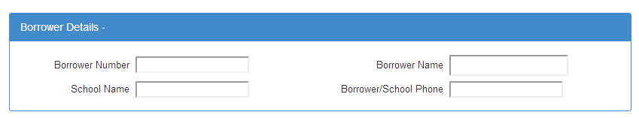

Escalated Issues

In addition to the fields in Figure 1, if the user selects Escalated Issue from the Issue Type dropdown list, the following fields will be available for completion.

* **Borrower Number:** The DMCS borrower number
* **Borrower Name:** The borrower’s name
* **School Name:** The name of the school involved (optional)
* **School Phone Number:** The phone number of the school involved (optional)

Figure 5: The reporting fields used to enter an Escalated Issue

Reporting

We can create whatever reports management requests from the data fields outlined above but presumably there would be a single “master report” which contains most of the fields in Figure 1 which are shared by all departments reporting issues. In addition, each department could continue to create reports customized to their own departments which addresses their own internal needs.